We like the one centered around brand colors more. A couple suggestions:
- Can we add more appropriate icons for what sets us apart, and our lines of business section. Current icons don’t make sense.
- Can we add actual links to research reports section and corporate disclosures. When we do that, we will need to format those pages with brand colors as well.
- ⁠How will the layout change for phone vs desktop
- Can we add logos of important clients near the Clients we Serve section
- Can you add bios from current website? We will refresh content once the format is finalized
- ⁠Can you provide other options for the modernized logo on top left?

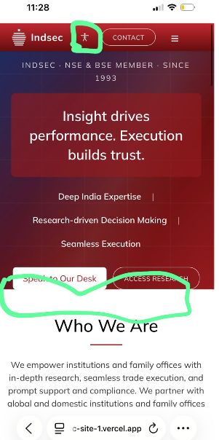
- What’s this icon next to the logo? Marked in green
- For the phone layout, we’ll need to add more red background at the back so buttons become clearer
- How to get started section (in gift city) … can we make it a process layout with a large arrow and four steps in it.
- Can you take the bios of the team from the current website

